Instruction:
Complete all questions in 1 hour.
- Which one is the characteristic of Harvard Architecture?
- Program and Data stored in Separate Memory
- Program and Data stored in same Memory
- Program and data stored in Cache Memory
- All Above

- Which of the following is the working cycle of CPU
- Decode, Execute, Fetch
- Fetch, Decode, Execute
- Fetch, Execute, Decode
- All Above

- Any condition that causes a processor to stall is called as _________
- Hazard
- Page fault
- System error
- None of the mentioned

- What does the control unit generate to control other units?
  - Transfer signals
  - Command Signal
  - Control signals
  - Timing signals

- What do the processors of all computers must have?
  - Control unit
  - ALU
  - Register
  - All of these

- Which is the fastest memory in the computer?
- Cache
- RAM
- Register
- Hard disk

- With the help of _______ we reduce the memory access time:
  - SDRAM
  - Cache
  - Heaps
  - Higher capacity RAMs

- For a given FINITE number of instructions to be executed, which architecture of the processor provides for a faster execution?
  - ISA
  - ANSA
  - Super-scalar
  - All the mentioned

- A processor performing fetch or decoding of different instruction during the execution of another instruction is called ______
  - Super-scaling
  - Pipe-lining
  - Parallel Computation
  - None of the mentioned

- A 24 bit address generates an address space of ______ locations.
  - 1024
  - 4096
  - 2⁴⁸
  - 16,777,216

- The USA contains about 3100 counties. Suppose you have a table that stores, for each county, its name (up to 40 characters in 8-bit ASCII), its state (a two-letter code), its population, and its median income (both as 32-bit numbers). How much space would the whole database take in memory?

= 3100*(40*8 + 2*8 + 32 + 32) bits
=1240000 bits
= 1240000/8 bits = 155000 bytes
= 155000 bytes/1024 = 151.3671875 KB

- The computer has a maximum addressable memory of 16 Gigabytes. Its address bus width is 32.
- Calculate the width of the data bus.

Here,
2³² * X = 16 GB = 16777216 KB = 137 438 953 472 bits
X = 137438953472 / 4294967296
X = 32 bit

- State the effect that adding one new line to the address bus would have on the maximum addressable memory.

Previously, we had 32-bit address bus.
By adding 1 bit to the address bus width,

2³²⁺¹ = 8589934592 bits

Here, by adding 1 bit to the width of the address bus, the total addressable memory almost doubled.

Let X = Total Memory
2³³ * 2² = X
2³⁰ * 2⁵ = X
∴ X = 32 GB

So, just by adding 1 bit to the width of the address bus, we can double the size of the total memory.

- Explain the Instruction cycle of the processor by taking an example of the program

Load: [10]
Add: [11]
Store: [12]
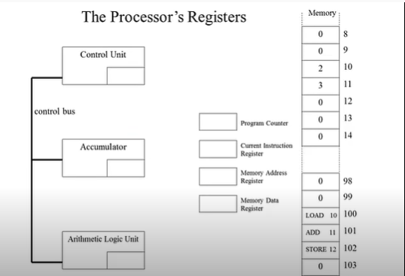

CPU works in cycles. The cycle is divided into 3 steps: Fetch Decode and Execute. These three steps are described in brief:

Fetch:
The fetching step is where the instructions and data are carried from the memory (cache or the main memory). The instructions and data are stored in the memory data registers. After fetch, the next step is to decode the instruction.

Decode:
In this step, the instructions are decoded by the control unit and sent to the ALU accordingly. Various computers have various length for instructions. For example, the above instruction LOAD may differ in size according to the computer. The LOAD instruction fetches the data from the given address. And ADD instruction adds the given two inputs. All these instructions are decoded to be executed in the decode phase.

Execute and Accumulate:
After the instructions and data are fetched and decoded, they are sent to the corresponding logic or arithmetic functional units of the ALU. And the output from the ALU is stored in the accumulator registers of the CPU.

The given instructions LOAD, ADD and STORE are the exact behaviour of CPU. Firstly, the value 2 is loaded from the memory address 10 with the instruction LOAD 10. And the ADD instruction loads the value 3 from the memory address 11 and performs an addition operation inside the ALU which is automatically stored in the accumulator of the CPU. The final STORE 12 instruction transfers the result in the accumulator to the memory address 12 in the main memory.
All the instructions are also stored in the main memory which is tracked by the program counter and current instruction registers. After each fetch the current instructions are updated. And the fetch gets the instructions from the memory stored in the current instructions register.

- Write short notes on the following topic:
- Von Neumann and Harvard Architecture
In 1945, computer scientist John Von Neumann presented new
architecture of computer which is called Von Neumann architecture. In this architecture he designed the computer memory to store the programs or instructions and the data all in the same place. This had its own pros and cons. With this structure, the main benefit was the simplicity of the architecture, and less memory division meant less memory management. But because data and the program instructions are stored in the same memory unit, the execution took longer and the condition of hazard was there. Hazard is when big amount of data is tried to read from the memory and the CPU stalls because of the high traffic of data.

In Harvard Architecture, the Von Neumann architecture was modified by splitting the memory into two subdivisions: program memory and data memory. In program memory only the instructions were stored, and the data memory consisted of the data used by the programs. By splitting the memory like this, the program execution became significantly faster as the data and instructions were simultaneously read from the memory. The CPU stalling problem was solved. But this architecture also had its own disadvantages: complex memory structure so complexity in memory management, waste of memory as the unoccupied memory could be used to store instructions, etc.

- RISC vs CISC architecture

RISC architecture stands for Reduced Instruction Set Computer which focuses on clock cycle optimization by simplifying the complex instructions into smaller simple instructions. RISC architecture is used in devices like mobile, tablets and thin laptops where there is no proper cooling. Since the RISC architecture simplifies the complex instructions into simpler ones, there is obviously less heating in the CPU in each cycle. But by this method, the execution may take longer time because for simple instructions, unnecessary clock cycles are required. The examples of the RISC based processors are ARM processors, Apple M1 processors, MIPS, etc.

But the CISC (Complex Instruction Set Computer) architecture is where instructions are optimized to be completed with the minimum clock cycles. Here the instructions are made more complex rather than simplifying. With this architecture, the computer works faster, but again the more complex instructions performed in the CPU per clock, more the heating issue. This type of architecture is used in open systems like Desktop computers and gaming computers. The examples of CISC processors are Intel processors, AMD processors, etc.

